**SDA LAB 9**

**K20-1052**

**BSE-4B**

**COMPONENT DIAGRAM**

**TASK 1**

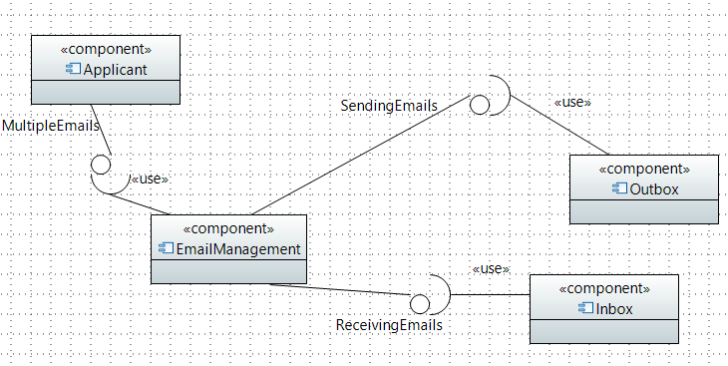

**TASK 2**

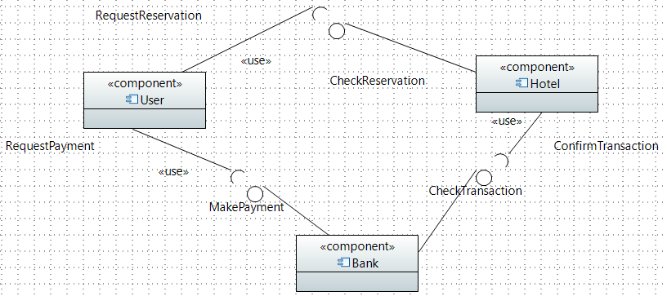

**TASK 3**

**Timing Diagram (FULL)**

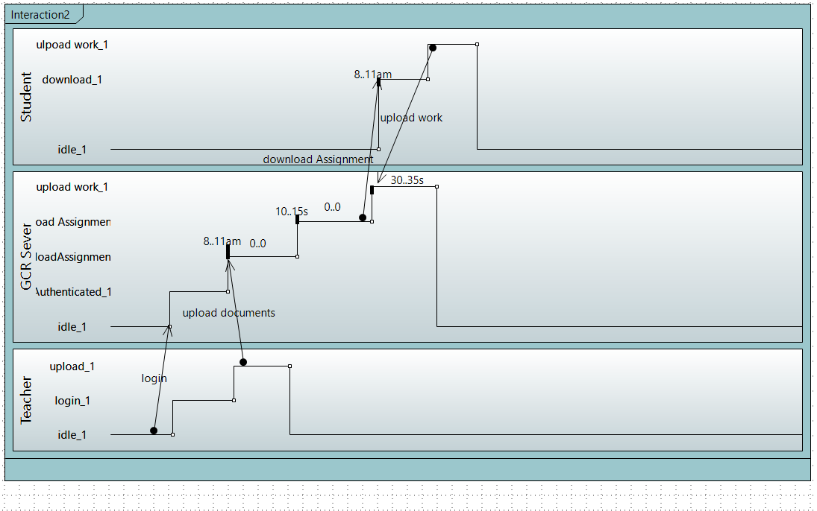

**Compact**

